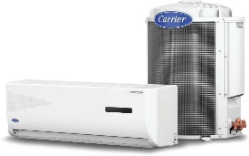
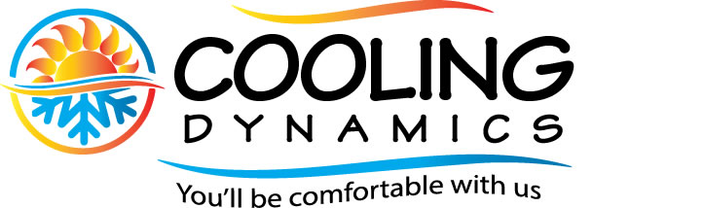
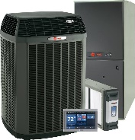

Specializing in Air Conditioning Service and Maintenance

Like any piece of mechanical equipment, having your HVAC equipment routinely serviced can prevent potential issues and avoid costly and inconvenient failures of the equipment. Cooling Dynamics offers a thorough and comprehensive scheduled preventative maintenance program consisting of the following:

Cleaning of condenser coils as well as evaporator coils ensuring the unit is processing the proper amount of air. Vacuum, flush, and treat drain line with an aggressive solvent to eradicate any buildup of organic growth. Flush and clean air handler drain pan. Assess all electrical components, including contactor, capacitor, and fan motors. Take amperage draws on all electrical loads. Assess “Delta T’ (discharge air temperature versus return air temperature). Assess operating temperatures and pressures of the system (refrigerant levels) to ensure the equipment is operating within specifications set forth by the manufacturer.

All manufacturers including RHEEM, TRANE, CARRIER and others strongly recommend these scheduled maintenances at least twice a year,

Your home cooling and heating equipment is a major investment and these scheduled maintenances provide numerous benefits among them are reduced monthly energy costs. HVAC equipment is designed to process a specific amount of air per ton of capacity, so impeded or restricted air flow forces the equipment to work harder than it was designed to, resulting in higher monthly electricity bills. Additionally, the added strain of restricted air flow can shorten the projected lifespan of 10-12 years set forth by the manufacturer. Premature failures can many times be directly attributed to neglect and lack of maintaining the equipment properly.

Filters
Keeping dust and dirt out of the evaporator is critical to your AC system's ability to function effectively.
Changing the air filters every other month is extremely important, even more so in homes with pets.
It is incumbent on the homeowner to keep up with these regular replacements and we cannot stress how important they are. Often systems require odd sized filters not readily available at your local Home Depot. Cooling Dynamics order and supply them at the customer’s request.

We encourage our customers to take a few minutes to discuss the process of servicing the equipment and feel free to observe exactly what is being done. It is our wish that you are an informed consumer and will certainly take the time to ensure this.

(954) 629-2706
(954) 849 COOL (2665)
DADE BROWARD PALM BEACH

